Anke Gilleir

**Hauptmann, Gerhart (1862—1946)**

Nobel prize winning playwright and novelist Gerhart Hauptman is mostly known as the pioneer of naturalism in German literature. In his lifetime he was considered one of the most prominent German authors worldwide. Although his voluminous oeuvre extends beyond the scope of naturalism, his life-long concern with the lower social classes and the destiny of man and humanity is characteristic of naturalist literature.

Hauptmann was born in the East-Prussian (now Polish) region of Silesia. After an unsuccessful school career and a disrupted artistic journey in Rome Hauptmann settled in Berlin. He burst upon the public as an author in 1889 with his play *Vor Sonnenaufgang* (*Before Sunrise*), a social drama about the decay of a Silesian peasant family that has unexpectedly grown rich. But prosperity has only brought drunkenness, incest and ruthless exploitation into the family, whose main victim is the youngest daughter Helene, who commits suicide. Social degradation and the image of man as genetically and socially determined shocked Germany's mainstream cultural audience. The conservative press scoffed the author for his moral decay, but the young literary scene hailed Hauptmann's play as the model of modern literature. Something similar happened with his drama *Die Weber* (1892, *The Weavers*, first played in Silesian dialect as *De Waber*), which was based upon the 1844 labourer insurrection in the Silesian weaving industry but clearly displayed contemporary destitution and suppression. Hauptmann's so called "class hatred" made the German emperor resign his loge in the "Deutsches Theater" after it staged the drama, but Hauptmann himself gained world fame and pursued his literary career unrelentingly. He also addressed social matters in a more humorous tone. His most famous comedy was *Der Biberpelz* (1893, *The Beaver Coat*), about the cunning and thievish protagonist Mutter Wolffen. The novel *Bahnwärter Thiel* (1888, *Gatekeeper Thiel*), whose simple-hearted protagonist is driven into insanity and murder, as well as dramas such as *Fuhrmann Henschel* (1899, *Drayman Henschel*) and *Rose Bernd* (1903) reveal how man is determined by both psychological and external forces. Of a different strand is Hauptmann's symbolic work. In his dramas *Hanneles Himmelfahrt* (1893, *Hannele's Assumption*), *Die versunkene Glocke* (1896, *The sunken Bell*) and *Und Pippa tanzt* ! (1906, *And Pippa Dances*) personal experiences merge with the mythical and semi-religious. This romantic direction left his progressive supporters at a loss, but it served Hauptmann to express a tormented disposition. The fictional diary *Buch der Leidenschaft* (1929, *Book of Passion*) deals with his inner conflict caused by the love for two women. Also on a political level Hauptmann revealed an uncertain attitude. His staunch patriotic defense of the German offensive in 1914 shocked the international intellectual world (Hauptmann had received the Nobel Prize only two years before). After the war he became one of the main supporters of the Weimar Republic, but failed to take a clear position against National Socialism when it was needed. Experiences of deep passion and pain founded his fascination for the Dionysian dimension of Greek culture. After his journey to Greece Hauptmann wrote the confessional travel novel *Griechischer Frühling* (1907, *Greek Spring*). His continued interest in Greek antiquity was conveyed in his rewriting of the Eurepidean *Atridentetralogie* from 1940 onward, which became his last major literary enterprise.

**References and Further Reading**

Primary Texts

*Before Dawn* (1889)

*The Weavers* (1892)

*Lineman Thiel* (1888)

*Drayman Henschel (1899)*

*Hannele's Assumption* (1893)

*The Beaver Coat* (1893)

*The Sunken Bell* (1896)

*Rose Bernd* (1903)

*And Pippa Dances !* (1906)

*Griechischer Frühling* (Greek Spring, 1907, not translated in English)

*Heretic of Soana* (1918)

*The Island of the Great Mother or the Miracle of the Isle des Dames* (1924)

*Buch der Leidenschaft* (*Book of Passion*, 1929, not translated in English)

*Ihpigenie in Delphi*  (*Iphigenia in Delphi*,1941, not translated in English)

Works on Gerhart Hauptmann

Gross, R.F. (1998*) 'Furhmann Henschel* and the Ruins of Realism', *Theater Journal* 50 (3): 319-334.

Leppmann, W. (2007), *Gerhart Hauptmann. Eine Biographie*. Berlin: Ullstein.

Marshall, A. (1982) *The German Naturalists and Gerhart Hauptmann: Reception and Influence*. Bern : Peter Lang.

Maurer, W. M. (1992) *Understanding Gerhart Hauptmann*. Columbia S.C.: University of South Carolina Press.

Osborne, J. (1998) *Gerhart Hauptmann and the Naturalist Drama*. New York - London: Routledge.

Sprengel, P. (2012), *Gerhart Hauptmann. Bürgerlichkeit und großer Traum*. München: Beck.

**Paratextual Material**

Online access to Hauptmann's *Dramatic Works* edited by Ludwig Lewisohn <http://onlinebooks.library.upenn.edu/webbin/metabook?id=hauptmanndrama>

Biographical survey of the German Historical Museum <http://www.dhm.de/lemo/html/biografien/HauptmannGerhart/>

Poster for Hauptmann's play *The Weavers* by Emil Orlik (1897)

[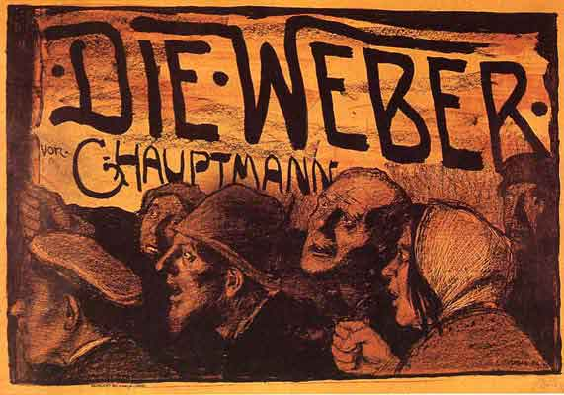](http://upload.wikimedia.org/wikipedia/commons/7/79/Die_Weber_1897_by_Emil_Orlik.jpeg)

Portrait of Hauptmann by Max Liebermann (1912)

[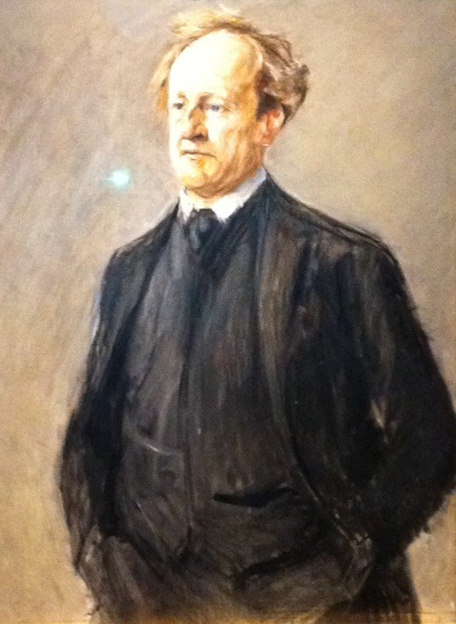](http://www.begleitschreiben.net/wp-content/uploads/2012/01/max-liebermann-gerhart-hauptmann-1912.jpg)